Water Cycle ThingLink Project
Part 1
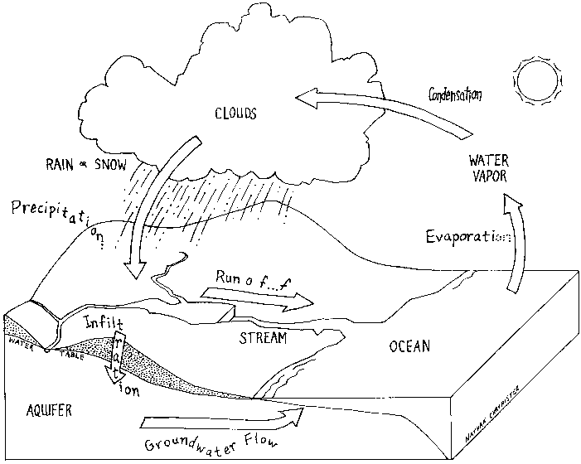
Your final project should be a THINGLINK that describes the water cycle and shows each step of the water cycle. (Don’t forget to include your name on the project.)
REQUIREMENTS:
1) DIAGRAM: On paper, you must quick draw a diagram of the water cycle to upload as the main picture into Pic Collage. Then, use Pic Collage to add arrows and vocabulary labels.
2) VOCABULARY: You must include the following terms (either typed or spoken) on your project:
- Evaporation
- Condensation
- Precipitation (rain, snow, sleet, hail)
- Runoff
- Groundwater/Collection
- Transpiration
- Vapor
3) MIXED MEDIA: Add tags giving more information about The Water Cycle, parts of the Water Cycle, and other interesting information about the Water Cycle. You must include at least one of each of the following types of media:
- Text
- Voice Recording (with typed caption of topic)
- 1 minute or less video (with typed caption of topic)
- Popplet
- Drawing
Part 2
Be prepared to share your project. Your test will be to describe/explain a diagram of the Water Cycle chosen by your teacher.
To show proficiency of the topic of the Water Cycle you must be able to:
- Describe the water cycle
- Explain the meaning of the steps of the water cycle
- Know the states of matter involved in the water cycle (when is the water a solid, liquid, or gas?)
- Explain your project and how it depicts the water cycle

Your project is due on ____________________.

Type in these links below, or check out Mrs. Christenson’s Class website to find these great Water Cycle Science links!
http://earthguide.ucsd.edu/earthguide/diagrams/watercycle/
http://ga.water.usgs.gov/edu/watercyclesummary.html
http://www.epa.gov/ogwdw000/kids/flash/flash_watercycle.html
http://teacher.scholastic.com/activities/studyjams/water_cycle/
http://www.dnr.state.wi.us/org/caer/ce/eek/earth/groundwater/watercycle.htm
http://www.windows.ucar.edu/tour/link=/earth/Water/water_cycle.html
http://www.worldbookonline.com/wb/Login?ed=wb&tu=%2Fkids%2FHome (User ID and password are gvsdwb)

Water Cycle Project Grading Rubrics
Name: _________________
Part #1 – Visual Aid
 | Possible Points | Your Points
Project on Time | 10 points
Neatness | 10 points
Quality of Work | 10 points
Vocabulary  - Evaporation  - Condensation  - Precipitation (rain, snow, sleet, or hail)  - Runoff  - Groundwater or Collection  - transpiration | 20 points  (2 points each)
 | Total Points | ______/50 points

Part #2 - Understanding of Water Cycle
 | Possible Points | Your Points
Overall Understanding | 25 points
Parts of Cycle | 5 points
Vocabulary | 5 points
What ifs | 5 points
Complete Thoughts | 5 points
Eye Contact | 5 points
 | Total Points | ______/50 points

